Daily Report

Department: CSE - (CyS, DS) and AI&DS
Date:16-March-2026

- Staff Attendance:

S.No | Dept. | Category | On Rolls | Absent | Details/Remarks
 | CSE - (CyS, DS) and AI&DS | Teaching | 69 | 06 | Faculty – On Duty  Faculty – Casual / Earn Leave  a.Full Day  1. Dr. Talluri Sunil Kumar(01-03-26 to 30-06-26)  2. Dr. Bommisetty Durga Venkata Chandra Mohan Rao  Reddy(FN)  3. Mr.Velpula Vinay Kumar  4. Dr. Kriti Ohri(10-03-26 to 20-03-26)  5.Mrs.V.Susmitha(04-03-2026 to 05-04-26)  6.Ms. Nam Vasundhara  b. Half Day  1. Nidamanuri Sudheer(FN)  1.Faculty – Half Pay Leave  1 Faculty - Study Leave  1.Mrs. Dr.T. Preethi  2.Ms.Issac Neha Margaret  3.Mr.K.Sai Bhargav  0 Faculty - Maternity/Paternity Leave
 |  | Non- Teaching | 13 | 02 | 0 Staff– On Duty  Staff- Casual / Earn Leave  a.Full  - Karri Vandana  - Gunreddy Laxma Reddy  - Staff– Half Pay Leave  0 Staff -Study Leave  1 Staff – Maternity/Paternity Leave  - Mrs. A. Shobha

- Infrastructure issues or Maintenance:

S.No. | Description of the problem | Reported  On | Attended  On | Completed on | Remarks
1.

- Event (short term course / workshops/Seminar, etc.) organized:

S.No | Name of the Event-seminar/ short term course / workshops,etc | Duration | For Whom | No. of Participants |  | Resource  Person/Faculty | Remarks
 |  |  |  | VNRVJIET | Others

- Participation by Staff & Students

S. No | Name | Event | Status | Date and Duration

Participation by Staff and Students:

S. No | Name | Event | Status (delegate /paper) Present, speaker) | Date and Duration
- Staff joined or left

S.No | Name of the Faculty | Designation | Date of Joining/leaving | Remarks

- Classwork Adjustment / Lectures Interchanged:
S. No | Dept | Subject | Time | Adjusted from | Adjusted to
1 | CSE – (CyS,DS) and AI&DS | III B.Tech DS B BDC | 10:00 pm to 11:00 pm | Mr.V.Susmitha | Mrs.A.Jaya Bhargavi
2 | CSE – (CyS,DS) and AI&DS | II B.Tech AI&DS MFDS | 2:40 pm to 3:40pm | Ms.Kriti Ohri | Mrs.A.Pravallika
3 | CSE – (CyS,DS) and AI&DS | IV B.Tech CyS Major Projects | 10:00 am to 11:00 am | Mr.N.Sudheer | Mr.B.Sangameshwar
4 | CSE – (CyS,DS) and AI&DS | I B.Tech DS A PPS | 12:40 pm to 3:40 pm | Dr. Bommisetty Durga Venkata Chandra Mohan Rao | Mrs.P.Devika
5 | CSE – (CyS,DS) and AI&DS | II B.Tech DS B PSASE Lab | 1:40 pm to 2:40 pm | Ms.N.Vasundhara | Mrs.M.Alekhya

S.No | Name | R. No. or ID No. | Brief statement | Remarks

- Any other matter to be reported:

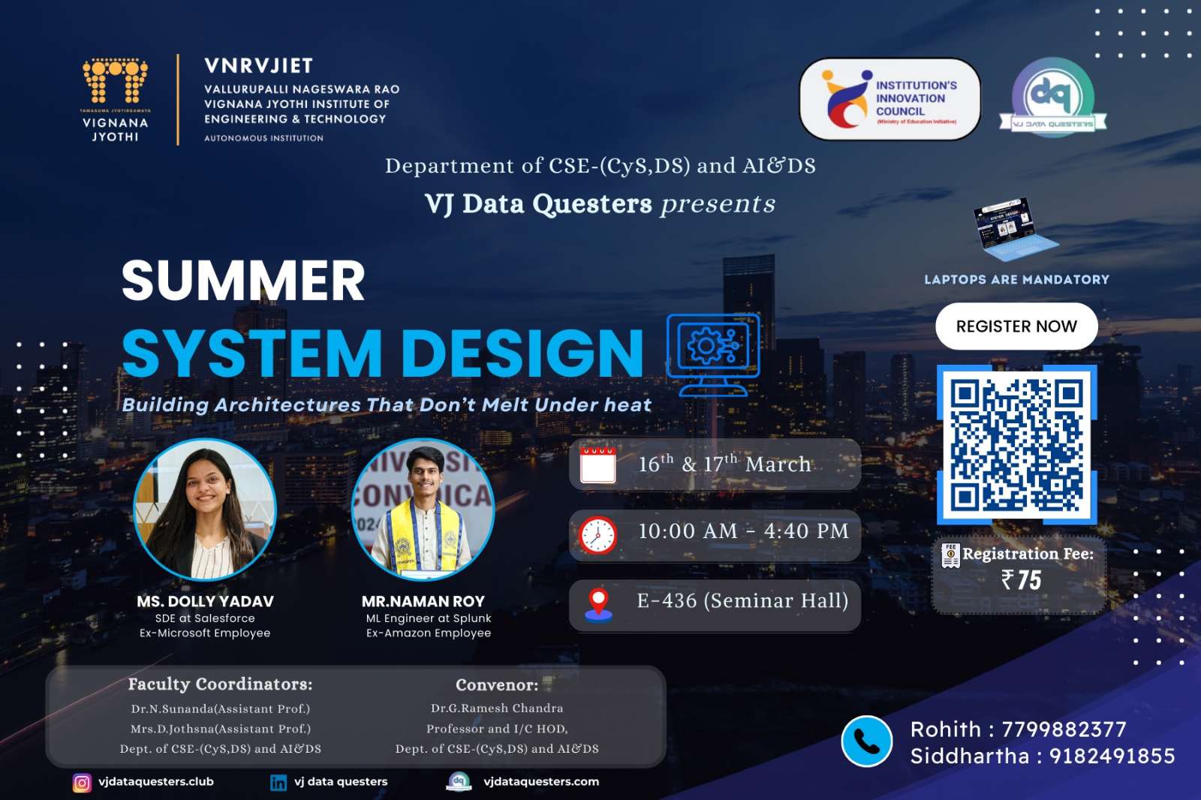

The Summer System Design Workshop at VNRVJIET brought together aspiring engineers for two days of intensive learning on building resilient architectures. With expert insights from industry professionals Ms. Dolly Yadav (Salesforce, ex-Microsoft) and Mr. Naman Roy (Splunk, ex-Amazon), participants explored practical approaches to system design. The sessions ran from 10:00 AM to 4:40 PM, combining theory with hands-on practice. Enthusiastic student participation and faculty coordination ensured a productive and engaging experience.

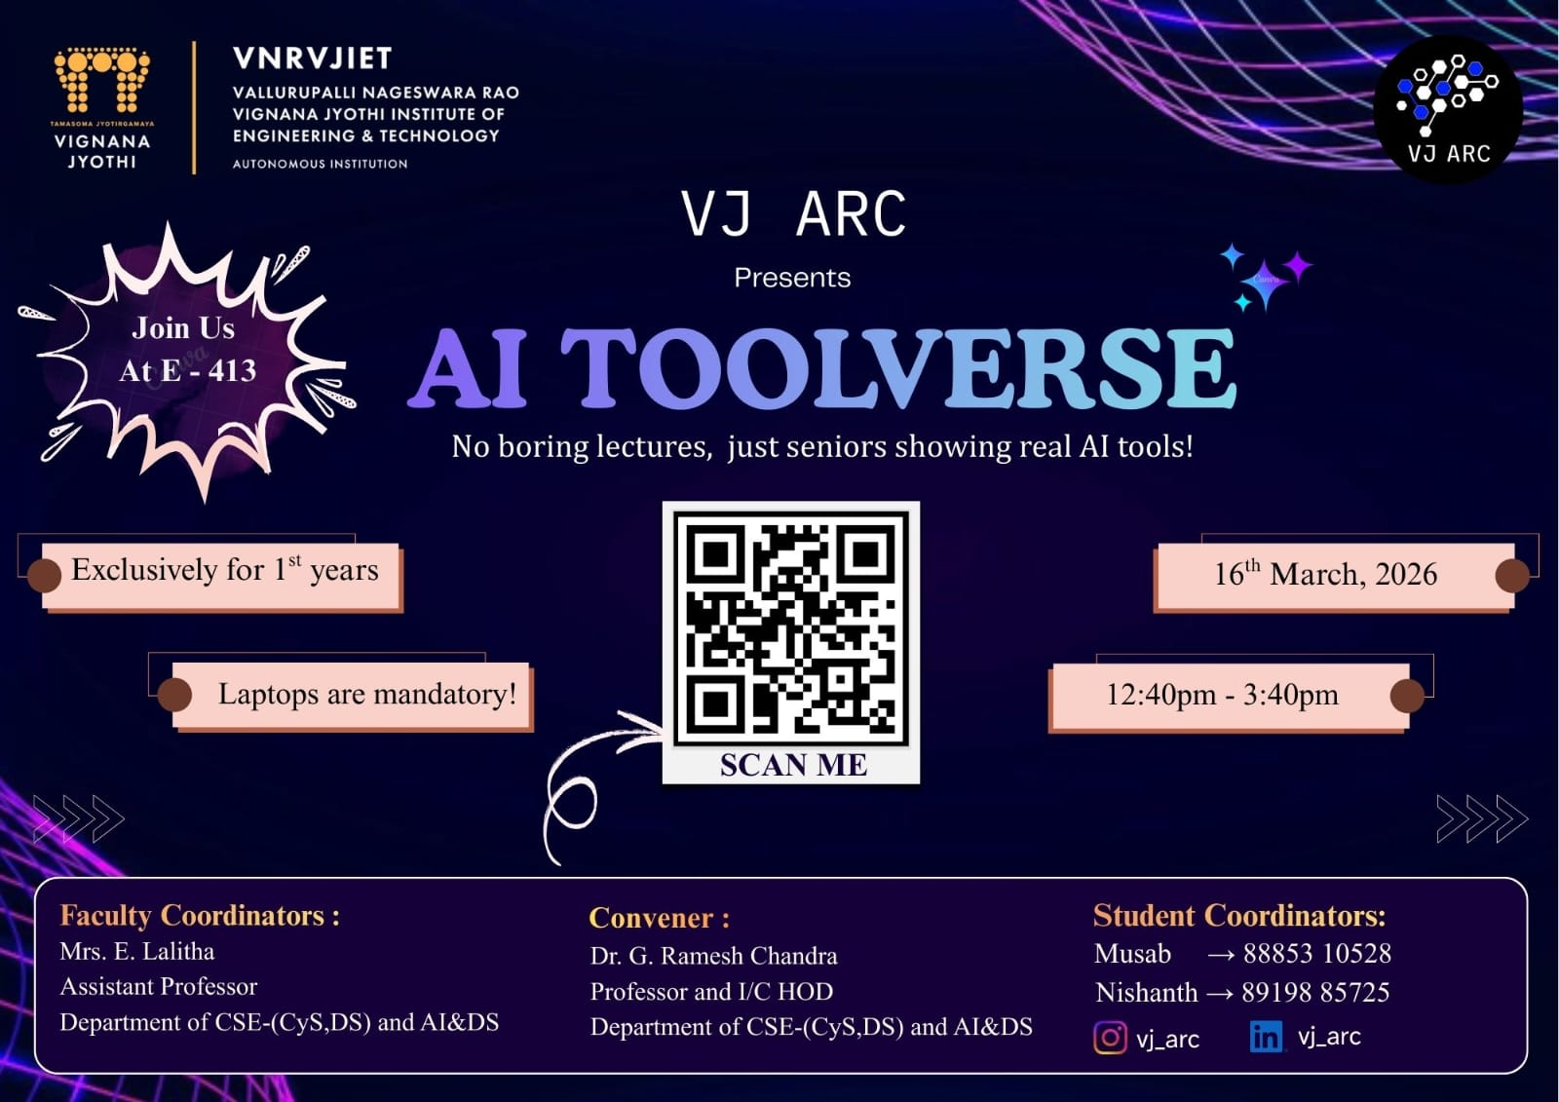

Attended 100 students
the AI Toolverse session organized by VJ ARC, where seniors demonstrated practical AI tools and their real-world applications. Explored different tools that can help improve productivity, learning, and project development. The session was interactive and provided useful insights into how AI can be applied in academics and daily tasks.

Dr. G.Ramesh Chandra
Prof. & I/C HOD
CSE-(CyS, DS) and AI&DS

